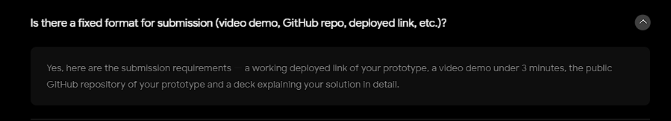
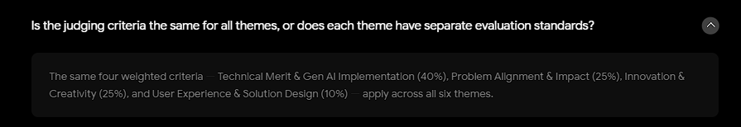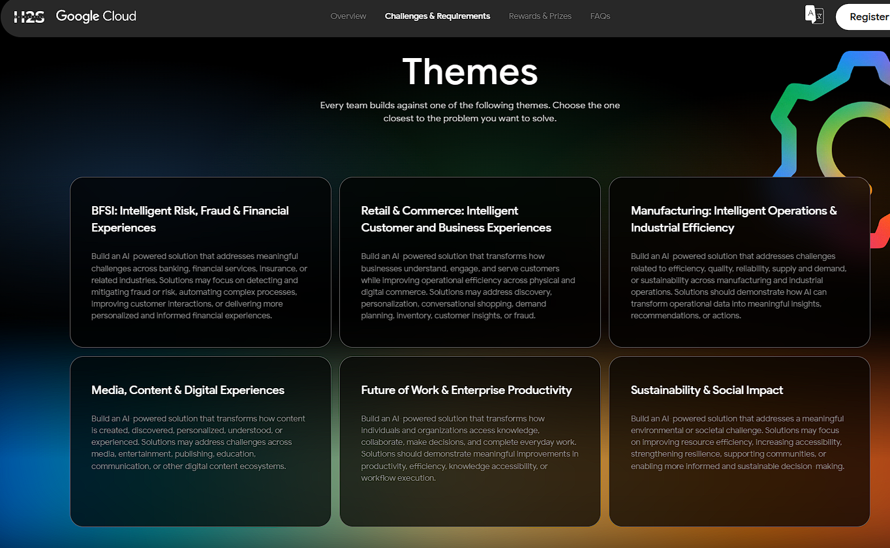

Chosen Theme
chosen track - media content & digital experiences. track description: Build an AI powered solution that transforms how content is created. discovered, personalized, understood, or experienced. Solutions may address challenges across media, entertainment, publishing education, communication or other digital content ecosystems.

Prompt used:
instead of pasting link to initiate the whole learning mode or creating AI short videos, i want to integrate to what already existing which is Google Product Youtube Shorts where you can scroll throught short video like reels. the flow would be user scroll to a videos that elicit his / her interest and would like to dive in more these kinds of video, instead of relying on algorithm to suggest to her in her upcoming or future videos (might be mixed up with his / her other interest, which make youtube shorts to show her other interested video next up), i want youtube shorts to create a isolated distinct space for user to explore on its interest from that particular videos she wanted to dive into. let say fixing a water pipe ... so in that space, there is menu that say browse more (she can find all the related video of fixing water pipe instantly for reference) which each video she can trigger to determine whether the video is relevant helpful or not, it can shrink and focus and refine whats her interest. also another menu, which is kind of summary context, an be shown in a summary generated combine of video with each chapter categorized such as buying and choosing a new water pipe from several videos that she liked and find it relevant and combine and summarize, find any gap reconcilliate,, this feature can save her time to compare manually and rewatch all the videos. with that have a section to inform user what is the gap found , and further add her feedback to clarify what her intention or goals (this will modify her summary generated combine of video), finally have a menu where she can keep and track her new summary generated combine video, even can post it has her new content but citing what each source coming from (with original video link where the AI extract and combine from the original video.

Theme 4: Media, Content & Digital Experiences
- Build an AI-powered solution that transforms how content is created, discovered, personalized, understood, or experienced. Solutions may address challenges across media, entertainment, publishing, education, communication, or other digital content ecosystems.

Proposal:
Trying to solve doomscrolling (extensive screen time usage), copyright infringement, explicit and violent content like Roblox gameplay reaching kids audience , better parental control mode (parent can devise a plan on what kind of content their children can watch)
Business opportunities: Income from being social influencer help 9-5er to generate side income by being social influencer, facilitating for formation of social content company, exploit every way possible to advertise business products using social media platforms instead of traditional ads. (Nowadays, social creator spamming post by asking algorithm to find the most trend videos and post it to generate views. Refer picture below) –
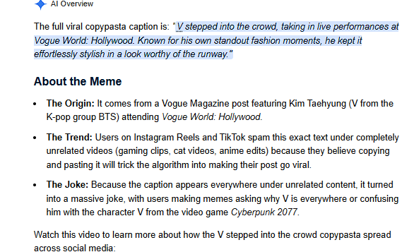

Generate educational content like national geography for animal lover and wildlife bioligist / kindergarten kids (generate AI video for them to better learn new phrases or abc alphabet intead of brainrot content like Fruit Person Character with drama , CocoMelon and PePega Pig. If you like to learn to fix a water pipe from watching video, combine and reconcilliate to find the gap of multiple source of videos fixing water paip and accomode which way of fixing pipe most suitable for your scenario. Generate a digital copyrigth hash or certificate derived from business license and video content to solve copyright infringement reposting other person video to gain more views or videos by altering or muting video
Loads of AI video, undermine or disrupt original work of true video artist, need copyright

Other Theme
Theme 2: Retail & Commerce: Intelligent Customer and Business Experiences
- Build an AI-powered solution that transforms how businesses understand, engage, and serve customers while improving operational efficiency across physical and digital commerce. Solutions may address discovery, personalization, conversational shopping, demand planning, inventory, customer insights, or fraud.

Proposal:
Ecommerce Shopping, let users find and survey desired item directly using sentence prompt (might include requirement and description of dress they looking for, dress code and function they attending to), can include image recognition if they have pictures of dress they looking for and further refine in prompt, price model comparison, call for external website hook for latest trend relevancy, provide mock up tool for user to draw the dress, personalized fit to body try on comparison with diffferent backgrounds theme, personalized body size, height , weight, waist size – cut out time wasted on buying and finding the right fit.
Additional point – customer insight, stock demand prediction model based on season, item website visited time, …

Theme 3: Manufacturing: Intelligent Operations & Industrial Efficiency
- Build an AI-powered solution that addresses challenges related to efficiency, quality, reliability, supply and demand, or sustainability across manufacturing and industrial operations. Solutions should demonstrate how AI can transform operational data into meaningful insights, recommendations, or actions.

Proposal:
Intelligently make business decision on bottleneck or aspect can be improve throughout the supply chain from supplier to manufacturer to possible cut down unnecceassary middle person with other replacement, adapt new AI automation solution to replace manual process such as inventory counting and invoice generation. Predict in advance what raw materials shortage and look for third party supplier in advance with lower cost. Predict in any manufacturing process that potentially cause downtime – human workforce burntout, machine overheat, outdated machine model (calculate the ROI of purchasing new machines vs remain with old machines)

Theme 5: Future of Work & Enterprise Productivity
- Build an AI-powered solution that transforms how individuals and organizations access knowledge, collaborate, make decisions, and complete everyday work. Solutions should demonstrate meaningful improvements in productivity, efficiency, knowledge accessibility, or workflow execution.
Proposal:
Reddit or PinInterest but enteprise version with internal access. Let employees have casual chat and knowledge sharing but can summon knowledge grounding bot to correct or rectify misinformation on the flow. Integrate a sandbox playground within the conversation ground, so that employees can test out their ideas whether it works. Problem trying to solve – misinformation or inaccurate information spreading, integrated workspace and conversation to try out different idea and get validate on the spot, lost track of knowledge trasition from previous PIC

Theme 6: Sustainability & Social Impact
- Build an AI-powered solution that addresses a meaningful environmental or societal challenge. Solutions may focus on improving resource efficiency, increasing accessibility, strengthening resilience, supporting communities, or enabling more informed and sustainable decision-making.
Problem to solved: Unified platform for pupply love adoption, gather people to commit to volunteer good act, disaster relieved personnel, create digital recognizable cert for NGO to avoid fraud and scam.

